Separating Mixtures & Making Solutions

Part A: Separating Mixtures
Filters are at work in your body, in your car, and in your home. How do they work? Which components are they able to separate from mixtures?

Question:
How can the process of filtration be used to separate the parts of a mixture?

Hypothesis:

If_____________________________________________________________________________________________________________________then_____________________________________________________________________________________________________________________________

Safety:
List 2 safety rules for this lab:
1.

2.

Variables:
- Manipulated Variable:

- Responding Variable:

- Control Variables:

Materials:
- funnel
- retort stand
- ring clamp
- 250mL beaker
- filter paper
- 2 premade mixtures
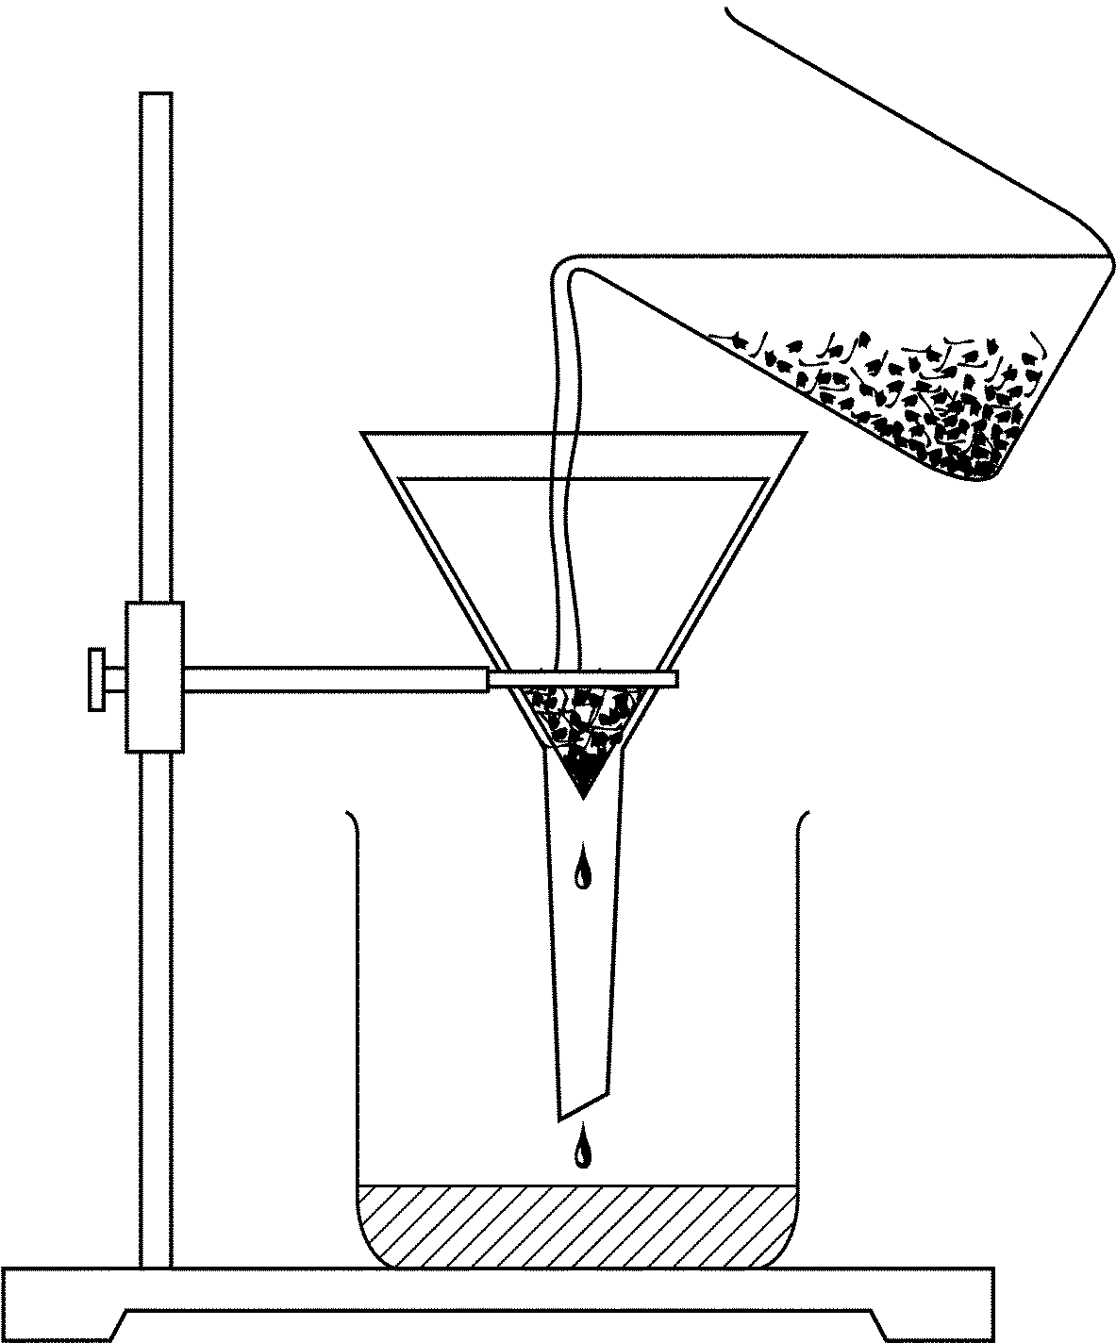
Procedure:
- Set up a retort stand, ring clamp and funnel as shown.

- Place a 250mL beaker below the funnel to catch the residue.

- Fold the filter paper as directed by your teacher and place it in the funnel. Dampen the filter paper with water so it will stay in place.

- Obtain your 2 premade mixtures. State observations about each one in the observation table.

- Pour a small amount of the mixture onto the filter paper. Be sure not to pour so quickly that you pour over the edges of the folded filter paper. The level of the mixture in the filter paper should be below the edge of the filter paper.

- Record your observations in the chart below.

- Discard the filter paper and clean the beaker. Get a new filter and set up the beaker again.

- Pour the second mixture into the filter. Record observations.

Observations:

Mixture | Observations | Appearance of filtrate | Appearance of residue
A

B

Analysis:
- Which mixtures were successfully separated by the filtering procedure? Why?

- Which mixtures were not completely separated by the filtering procedure? Why not?

- What kind of mixture do you think mixture A is? Mixture B? How do you know?

Conclusion:
- What other methods might be used to separate the mixtures you were unable to separate by filtering? List at least 3 methods.

Part B: Making Solutions

Question:
Does temperature affect the solubility of a solution?

Hypothesis:

If_____________________________________________________________________________________________________________________then_____________________________________________________________________________________________________________________________

Safety:
List 2 safety rules for this lab:
1.

2.

Variables:
- Manipulated Variable:

- Responding Variable:

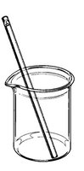
- Control Variables:
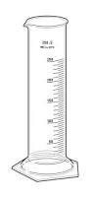

Materials:
- Drink crystals
- Water (cool & warm)
- Thermometer
- 2 – 600mL beakers
- Graduated cylinder
- Stirring rod
- Teaspoons

Procedure:
- Get 100mL of cold water from the tap. Pour into the beaker.

- Place the thermometer into the beaker and record the temperature in the observation table.

- Add one teaspoon of drink crystals to the beaker. Stir.

- Continue to slowly add one teaspoon at a time until you have made a saturated solution (the point at which you will see a few crystals – they have not dissolved).

- Record how many teaspoons of solute (drink crystals) you used in the observation table.

- Get warm water from the tap and repeat the steps above. Record in the observation table.

- Calculate the amount of solute you used for each in grams. Note: 1 teaspoon = 4 grams.

- Share your data with the class.

Observations:
Beaker containing 100mL water: | Temperature (degrees Celsius): | Amount of solute used (teaspoons): | Amount of solute used (grams):
Cool water
Warm water

Analysis:
- What is the concentration (g/L) of each beaker?

- Which temperature dissolved more solute? Why do you think it dissolved more?

- What are 2 sources of error for this lab?

- Using the class’s data, create a solubility graph.

Conclusion:
- Reviewing the solubility graph you made, what do you notice?

- What can you conclude from the solubility table?

- If a student adds 50g of sugar to 100mL water at 10 C, the resulting solution is best described as;
  - Saturated
  - Unsaturated
  - Supersaturated

- If a student adds 5g of sugar to 100mL water at 20 C, the resulting solution is best described as;
  - Saturated
  - Unsaturated
  - Supersaturated

